**IT 1090C Computer Programming I   
Lab 7 – Get Loopy**

**SPRING 2020  
20 Points (2 gr or extra credit)**

For this individual assignment, implement the Looping problems listed here. For each problem insert a screen shot of the output immediately after the loop description (I.E. don’t put them all at the end) Best to do these as you go rather than go back and do them after coding everything). Finally, give me your complete Netbeans project. (Just use a single project and main java class to do all 10 loops.) Name your Project **GettingLoopy**. Name your main java class **Loopy.java**

**Directions:**

**Part A: Counting (for) Loops (2 points each)  
(Don’t be clever and use a while loop! Make these for loops)  
Paste a Screen capture or output window copy to show each one.**

1. A loop that counts (i.e. displays the count) up by 1 from 0 to 30   
     
   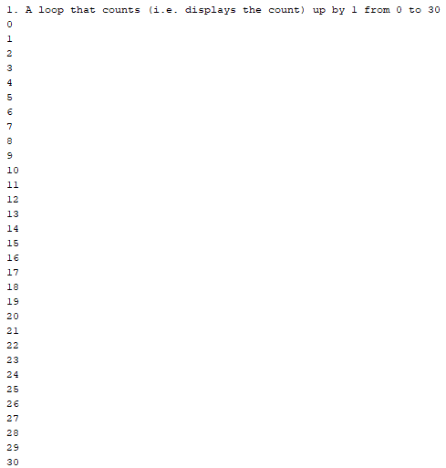
2. A loop that counts down by 1 from 30 to 0  
     
   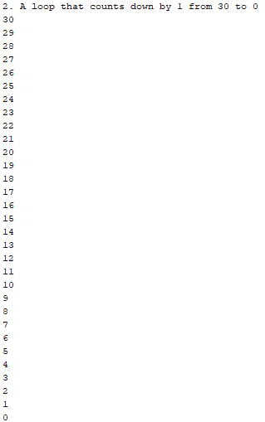
3. A loop that counts up by 3 from 0 to 18  
     
   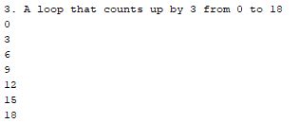
4. A loop that counts down by 2 from 10 to 0



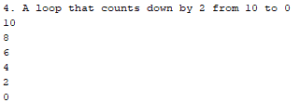  
**Part B: Output for loops (2 points each)  
Use nested for loops to do these. Again, paste the output copy or screen shot after each one.**

1. A nested loop that creates this figure (there are no blank lines)  
     
   *  
   **

***  
****  
*****  
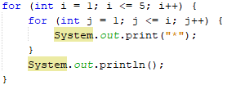



1. A nested loop that creates this figure (there are no blank lines)  
     
   *****  
   ****  
   ***  
   **  
   *  
   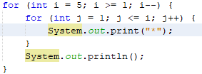  
   
2. A nested loop that creates this figure (there are no blank lines)  
     
   *****  
   *****  
   *****  
   *****  
   *****  
   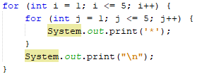  
   
3. (6 Points)  
   Redo either the F to C or C to F converter program.  
   Create a new Java Main File called **CtoF.java** or **FtoC.java**. (Don’t create a new project, just put it in the current project with the previous java main class.)

Use a do while loop to bulletproof the user input. Now, when the user fails to enter a valid number, the program will display an error msg and then loop and prompt them again to try again to input the value correctly. So, the program will block and repeat until they get it right. Be sure to thoroughly test your program. Include screen shots output copies here that show the tests and output.  
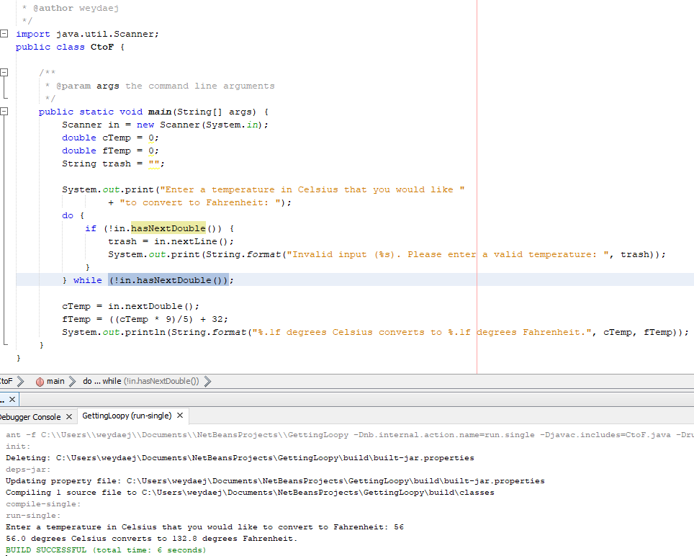



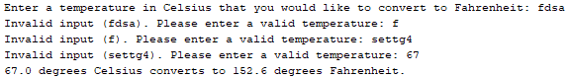

**Extra Credit or Graduate Option**: (2 points)

If you do this option create an additional java main class named **MyInitial.java**. Again just create it in the same GettingLoopy Netbeans project.  
  
Write a program that outputs an elaborate **capital** version of your first initial using * characters. (Note if your first initial is I use your last initial.) Use loop­**s** to print out duplicate lines in the character. Again no blank lines. Here the first loop would do the first 3 lines and a second would do the rest.  
  
 ******************  
 ******************  
 ******************  
 ***  
 ***  
 ***  
 ***  
 ***  
 ***

Provide the screen shot here:  
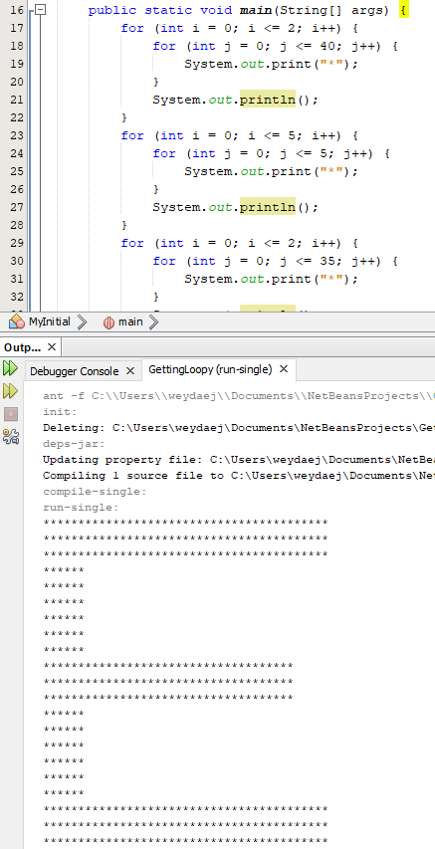  
**Submitting your work:**

Name your .zip Archive: **FirstName_LastName_Lab_07.zip.** Include your entire Netbeans project folder and this MS Word file with your output screen shots within the archive. Separately submit the archive and the docx file as before.